REAL ESTATE RESEARCH PAPERS

- Summary 1 [Academic Research Paper(target platform)]: ScienceDirect – Srinivasan, 2017
- Summary 2 [Academic Research Paper(target domain)]: Deakin Repository/DOI – Ullah et al., 2021
- Summary 3 [Business Case Study (Target Platform)]: UXCam – Housing.com Case Study
- Summary 4 [Business Case Study (Target domain)]: Oak Park Apartments Website Redesign by Mannix Marketing.
Summary 3 is not an proper “academic research paper”. It is a Business Case Study.
Summary 4 is a business/UX case study, not an academic research paper.

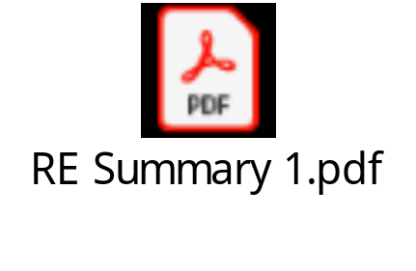
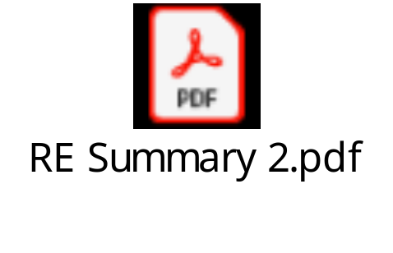
Links:
Summary 1-https://www.sciencedirect.com/science/article/pii/S0970389616301616
Summary 2- https://dro.deakin.edu.au/articles/journal_contribution/It_s_all_about_perceptions_A_DEMATEL_approach_to_exploring_user_perceptions_of_real_estate_online_platforms/20668233?file=36879084
Summary 3- https://uxcam.com/case-study/housing/
Summary 4- https://we-awards.com/winner/oak-park-apartments/

